1) http://192.168.5.131:3000/addOnlineInquiry
shows errors in non required fields
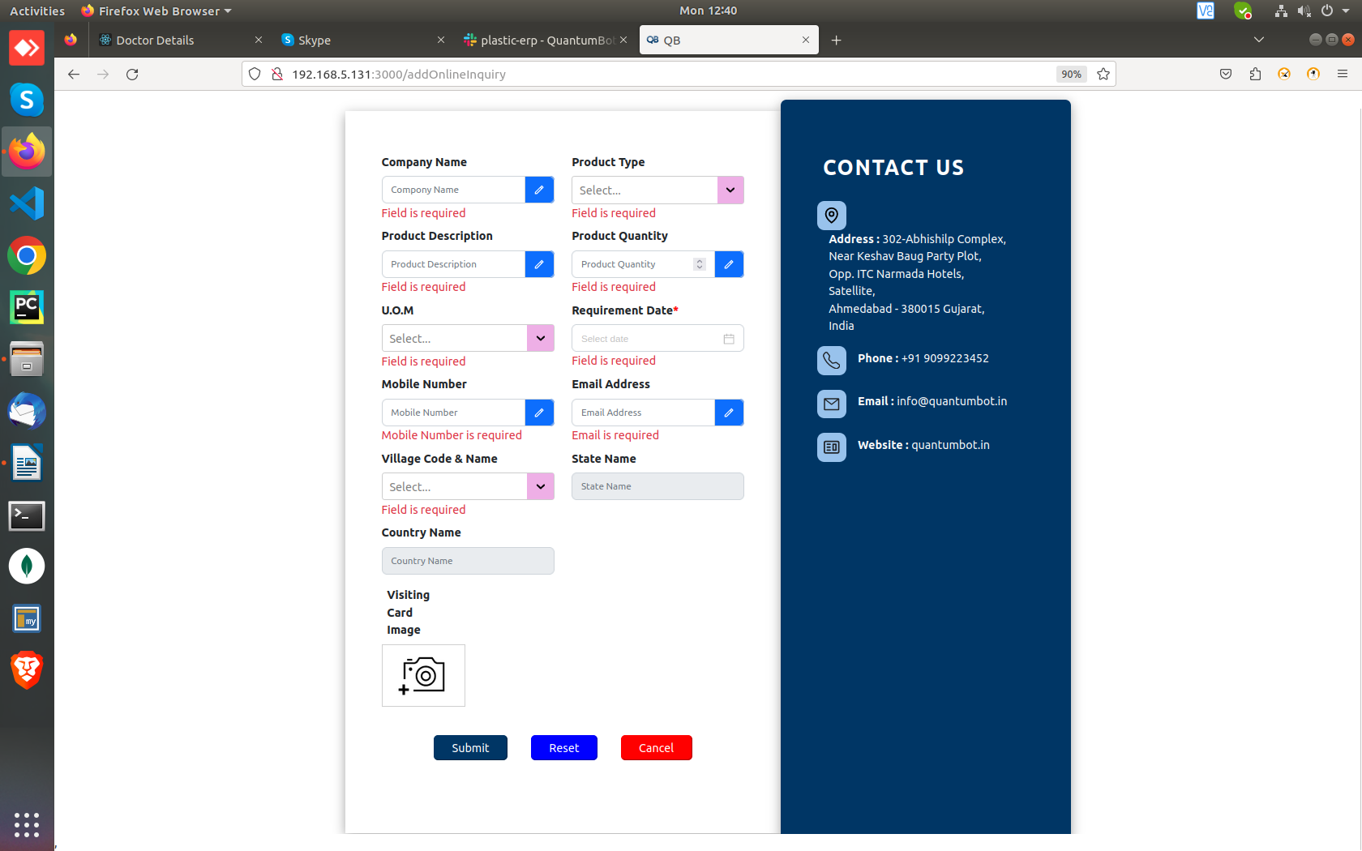
http://192.168.5.131:3000/AddCity
“Required field” messages not showing up
“City Name” placeholder
“Pincode” can be created of a single digit
“Reset” doesn’t work on district, state, country name
